Model Title Page

Factors Influencing Business Travellers’ Hotel Selection: A Case Study of Business Travellers in London

By: Author’s Name

Year of publication

Submitted in Partial Fulfilment of the Requirements for the Bachelor of Science BSc. degree.

Canterbury Christ Church University

Table of Contents
CHAPTER 3. RESEARCH METHODOLOGY 4
3.1 Introduction to Methodology 4
3.2 Methodological Framework: Application of Onion Model 4
3.2.1 Research Philosophy for the Dissertation 5
3.2.2 Research Approach for the Dissertation 5
3.2.3 Research Strategies/Design for the Dissertation 5
3.2.4 Choices for the Dissertation 6
3.2.5 Time Horizons for Dissertation 6
3.3 Data Collection Techniques 7
3.4 Analytical Techniques and Procedures 7
3.5 Ethical Issues 7
3.6 Chapter Summary 8
References 9

List of Figures
Figure 2: Saunders’ Research Onion 4

CHAPTER 3. RESEARCH METHODOLOGY

3.1 Introduction to Methodology
The method used to explore the determinants of hotel choice by business travellers in London is explained. The purpose of the research is to determine the significant factors affecting the choice of hotel, to explore the significance of location, comfort and service quality, and to review the preferences of business travellers with the help of existing literature (Gamage, 2025). For the study, a qualitative research design was used, and the data used for the study are secondary. As such, there is no primary data collection from the participants. The methodology is organised around the research philosophy, research approach, research strategy, type of data, time, data collection methods, analysis of data and ethical issues.

3.2 Methodological Framework: Application of Onion Model
The research methodology is organised using the principles of Saunders’ Research Onion. The model, which is systematic in nature, starts with research philosophy and then progresses to research approach, research strategy, and research methodological choices and finally research time horizon. In this dissertation, layers will be chosen based on the type of research questions and the utilisation of published secondary qualitative evidence (Saunders et al. 2023).
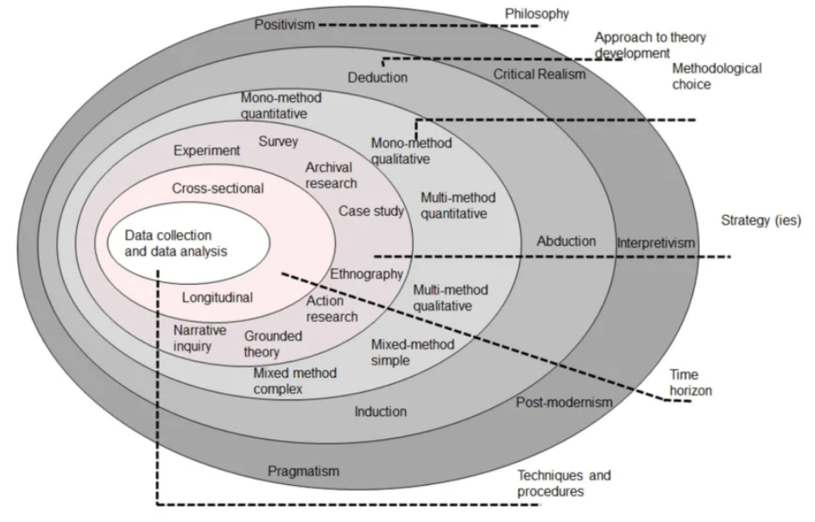
Figure 2: Saunders’ Research Onion
(Srouce: Research Gate, 2026)

3.2.1 Research Philosophy for the Dissertation
The study is based on an interpretivist philosophy. Interpretivism is suitable to use because the research is to understand the preferences, perceptions and decision-making factors of the business travellers' hotel choice, and not to measure their behaviour using numbers. Chapter 2 shows that the literature reveals multiple dimensions of hotel selection, including functional, psychological, technological and service dimensions (Saharan et al. 2024).
An interpretivist approach thus allows the researcher to investigate the significance of location, comfort and service quality, etc., as found in various studies in the context of business travel. This research does not make any assumption about the Hotel Choice criterion for all of the travellers, but takes the different explanations reported in the previous research. This is in line with the secondary data qualitative design of the study (Makateng and Mokala, 2025).

3.2.2 Research Approach for the Dissertation
An inductive research method is used. Induction is the process of analysing existing evidence and looking for patterns or themes in the data. It is useful because the study does not seek to prove an a priori statistical hypothesis. Rather, it provides a research report on published evidence to highlight common elements in the hotel selection process among business travellers.
The inductive approach is especially pertinent to the research objectives since the study's aim is to seek the key factors, determine the importance of location, determine the importance of comfort and quality service, and determine the preferences of business travellers. According to the literature, no single attribute is sufficient to explain the choice of hotel, and other attributes, such as technology, cleanliness, security, service and organisational requirements, etc., have an impact as well. Thus, the analysis was conducted in an inductive manner, which enabled themes to be identified from the literature being reviewed (Susilawati et al. 2025).

3.2.3 Research Strategies/Design for the Dissertation
The research method used in this study is secondary qualitative research, which is a structured literature review. The approach will be to gather and analyse data that has already been published in academic and professional sources. This is fitting as the research question can be answered by the existing evidence related to business travellers and the selection of a hotel.
The study does not involve questionnaires, interviews, observations or experiments. Academic journal articles, books, industry reports, government publications and reputable hospitality and tourism sources are used to obtain evidence, however. The ethics form explicitly states that the secondary qualitative data will be derived from published academic/industry sources (Verma et al. 2024).
This strategy also complements the research gap identified in literature review where past studies were reported to have looked at individual hotel-selection factors, but paid relatively less attention to the impact of the combination of location, comfort, and quality service on business travellers in London.

3.2.4 Choices for the Dissertation
The methodology adopted is of qualitative type and is mono-method, meaning that the research carried out is qualitative secondary evidence and not a combination of qualitative and quantitative primary methods. The main sources of information are peer-reviewed academic journal articles, books, industry reports, government publications, and hotel-industry reports and reputable information sources on the internet.
The literature search involves online searches of academic sources such as Google Scholar and ScienceDirect as well as trusted and reliable industry and institutional sources. The searching strategy is done on keywords directly related to the research topic. These are: “business travellers”, “corporate travellers”, “hotel selection”, “hotel choice”, “business tourism”, “hotel location”, “hotel comfort”, “quality service”, “hospitality industry”, “London hotels” and “hotel preferences”.
Relevant literature is reviewed in relation to the research aim and objectives. Special focus on evidence on location, comfort, quality service and preferences of business travellers. Theoretical and empirical support comes from academic sources, and contextual evidence regarding hospitality and business travel comes from industry and other trusted sources (Willie, 2024).

3.2.5 Time Horizons for Dissertation
Traditional time frames apply more logically to studies that collect primary data, since they indicate whether participants were studied at a single point in time or over a long period. Because this dissertation is based on secondary data, there is no participant observation or data collection over time.
Analytically, the study could be seen as a cross-sectional study because it integrates existing evidence to understand the factors influencing business travellers in the selection of a hotel during a trip. The analysis is not an attempt to follow individual travellers over time. Rather, it summarises results of published studies to draw out common and contrasting themes for the selection process of a hotel in London.

3.3 Data Collection Techniques
Data collection is an organised search and collection of existing secondary data. Relevant keywords are searched through the Academic literature for the identification of academic literature, using ScienceDirect and other reliable Academic literature databases, including Google Scholar. Where possible, the information is taken from industry reports, government publications and reputable websites in the hospitality and tourism sector (Islam et al. 2022).
The collected sources are sifted based on their significance to the study's questions and the study's purpose. Sources relating to business travellers, hotel selection, location, level of comfort, service quality and hotel preferences are given priority. The process guarantees that the evidence is directly related to the research questions, and does not contain a large amount of unrelated hospitality literature. The ethics documentation confirms that secondary information will be collected from online academic databases, electronic journals, books, industry publications, government reports and reputable hospitality and tourism websites.

3.4 Analytical Techniques and Procedures
Thematic analysis is used in analysing the collected secondary qualitative data regarding the study. Thematic analysis is suited to this purpose as a goal of the analysis is to identify patterns and themes that emerge across various published sources.
The analysis includes the review of the selected literature, identification of relevant findings, comparison of evidence from studies and grouping of similar evidence under the general themes. Specific focus on each of the themes concerning the location of the hotel, the comfort, the quality of the service and the preferences of the business traveller, in accordance with the research objectives. Thematic analysis makes it possible to synthesise results from various sources instead of presenting them as individual studies. Findings are also contrasted to yield a more critical interpretation of ‘business travellers' hotel-selection behaviour.

3.5 Ethical Issues
Ethical considerations are relevant in the collection and use of secondary information even in the absence of human participants in the study. All sources are treated responsibly, and suitable academic referencing is used to credit the original author. There is no intentional falsification or misrepresentation of information, nor is information removed from its context (Cheong et al. 2023).
The researcher also checks the reliability and credibility of the sources that they will use in the analysis. Academic journal articles, credible databases, government documents and well-known industry publications are highlighted. Because no personal or confidential participant information is gathered, risks associated with participant privacy and informed consent are not relevant to the research design. The ethics form states that the research being proposed is secondary qualitative data, not participant-based primary data.

3.6 Chapter Summary
The methodological basis of the dissertation is laid in this chapter. This study is interpretive in nature and has an inductive approach with a secondary qualitative research design. The primary evidence sources are existing academic writing, industry reports, government reports and reputable hospitality sources. Thematic analysis is employed to identify and combine emerging themes on the issues of hotel location, comfort, quality service and preferences of business travellers; and a structured search strategy is used to locate relevant literature using relevant keywords. Ethical practices are covered by responsible selection of sources, accurate representation and appropriate referencing. This methodology is appropriate for addressing the research questions and for analysing the data that will be discussed in the next chapter.

References
Cheong, H.I., Lyons, A., Houghton, R. and Majumdar, A., (2023). Secondary qualitative research methodology using online data within the context of social sciences. International Journal of Qualitative Methods, 22, p.16094069231180160. https://journals.sagepub.com/doi/abs/10.1177/16094069231180160
Gamage, A., (2025). Research design, philosophy, and quantitative approaches in scientific research methodology. Scholars Journal of Engineering and Technology. https://www.academia.edu/download/122341245/SJET_132_91_103c_published_paper.pdf
Islam, M.R., Khan, N.A. and Baikady, R. eds., (2022). Principles of social research methodology. Springer Nature. https://link.springer.com/content/pdf/10.1007/978-981-19-5441-2.pdf
Makateng, D.S. and Mokala, N.T., (2025). Understanding qualitative research methodology: A systematic review. E-Journal of Humanities, Arts and Social Sciences, 6(3), pp.327-335. https://noyam.org/wp-content/uploads/(2025)/03/EHASS(2025)637.pdf
Research Gate (2026). Accessed from < https://www.researchgate.net/publication/349083776/figure/fig1/AS:1020880498982914@1620408286466/Research-onion-Saunders-et-al-2019-p-108.png >. Accessed on 13/8/2026.
Saharan, V.A., Kulhari, H., Jadhav, H., Pooja, D., Banerjee, S. and Singh, A., (2024). Introduction to research methodology. In Principles of research methodology and ethics in pharmaceutical sciences (pp. 1-46). CRC Press. https://api.taylorfrancis.com/content/chapters/edit/download?identifierName=doi&identifierValue=10.1201/9781003088226-1&type=chapterpdf
Saunders, M., Lewis, P. and Thornhill, A. (2023) Research Methods for Business Students. 8th edn. Harlow: Prentice Hall.
Susilawati, A., Al-Obaidi, A.S.M., Abduh, A., Irwansyah, F.S. and Nandiyanto, A.B.D., (2025). How to do research methodology: From literature review, bibliometric, step-by-step research stages, to practical examples in science and engineering education. Indonesian Journal of Science and Technology, 10(1), pp.1-40. https://ijost.upi.edu/index.php/ijost/article/view/439
Verma, R., Verma, S. and Abhishek, K., (2024). Research methodology. Booksclinic Publishing. https://books.google.com/books?hl=en&lr=&id=tWP4EAAAQBAJ&oi=fnd&pg=PP1&dq=RESEARCH+METHODOLOGY&ots=WjX8fXibYd&sig=53eDO5cK6xbwD-IV4m-jIKOgfQk
Willie, M.M., (2024). Population and target population in research methodology. Golden Ratio of Social Science and Education, 4(1), pp.75-79. https://www.goldenratio.id/index.php/grsse/article/view/405

